

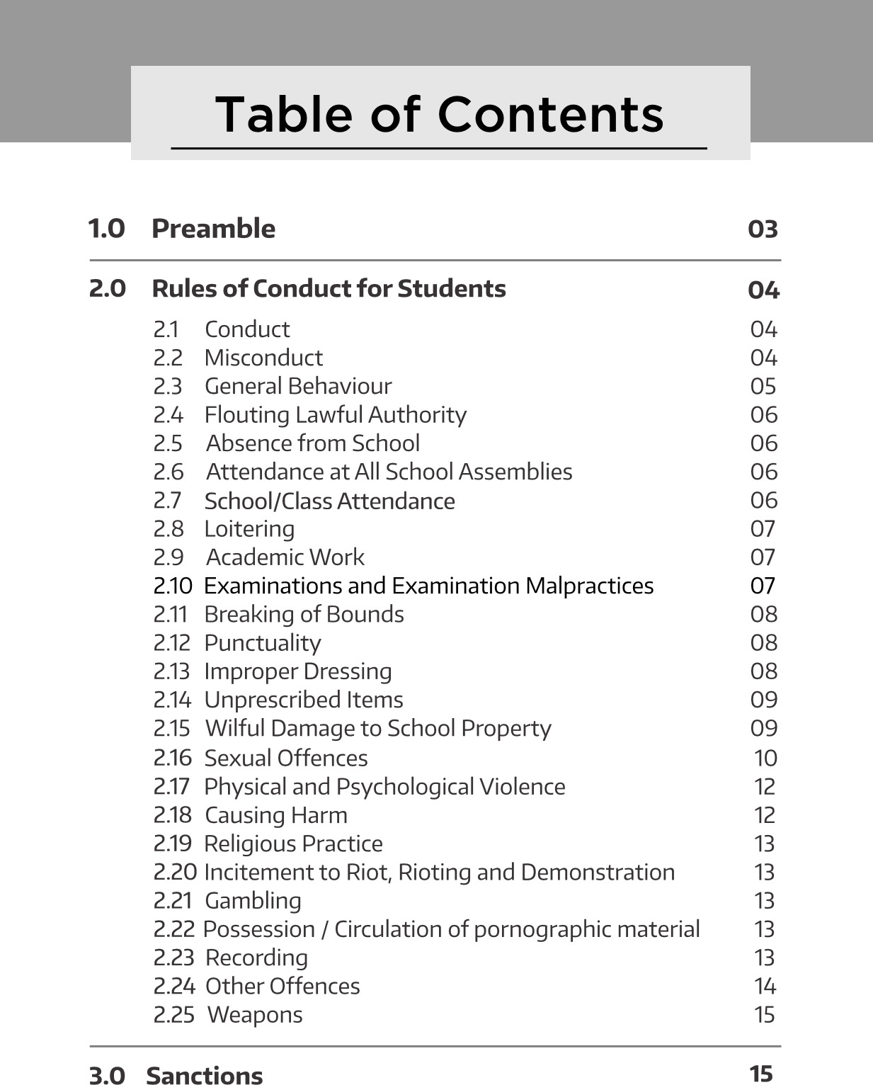

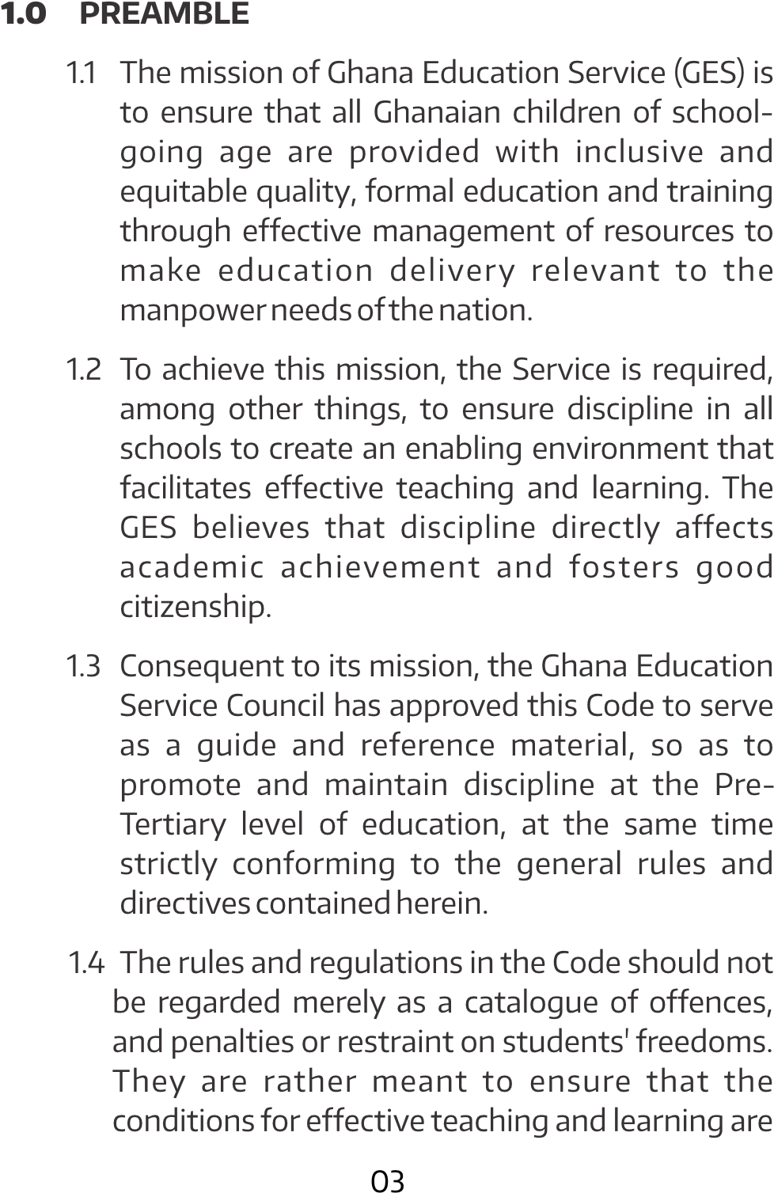

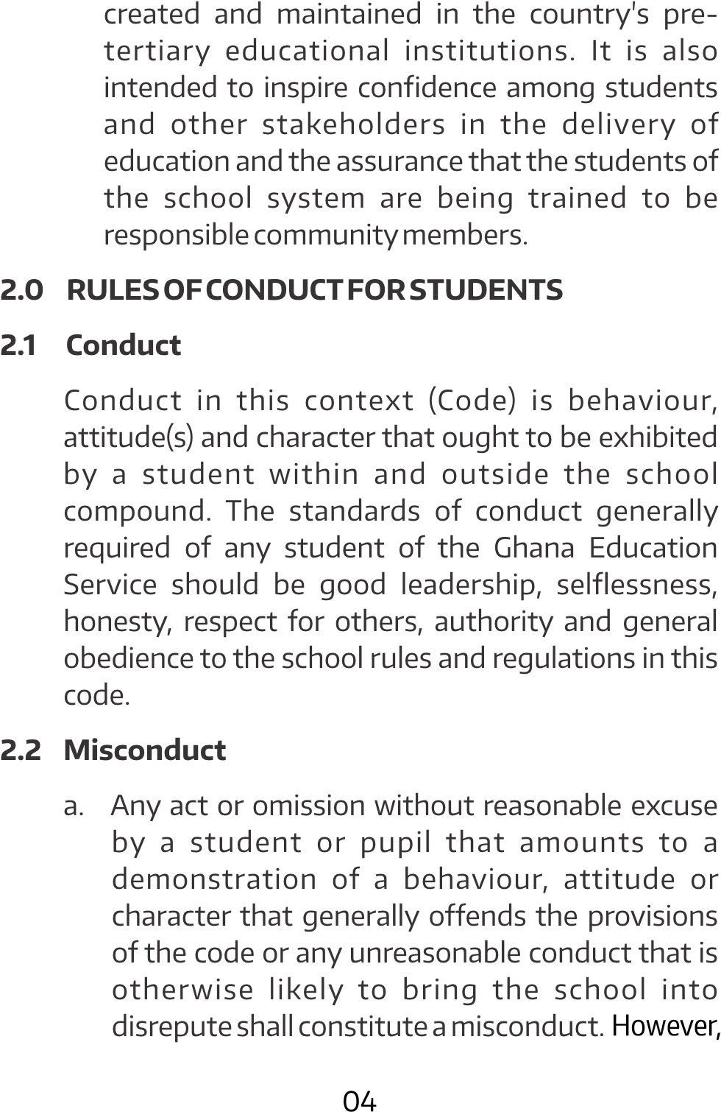

b. Any act of misconduct or non-observance of any of the rules and regulations in this code shall lead to disciplinary action.

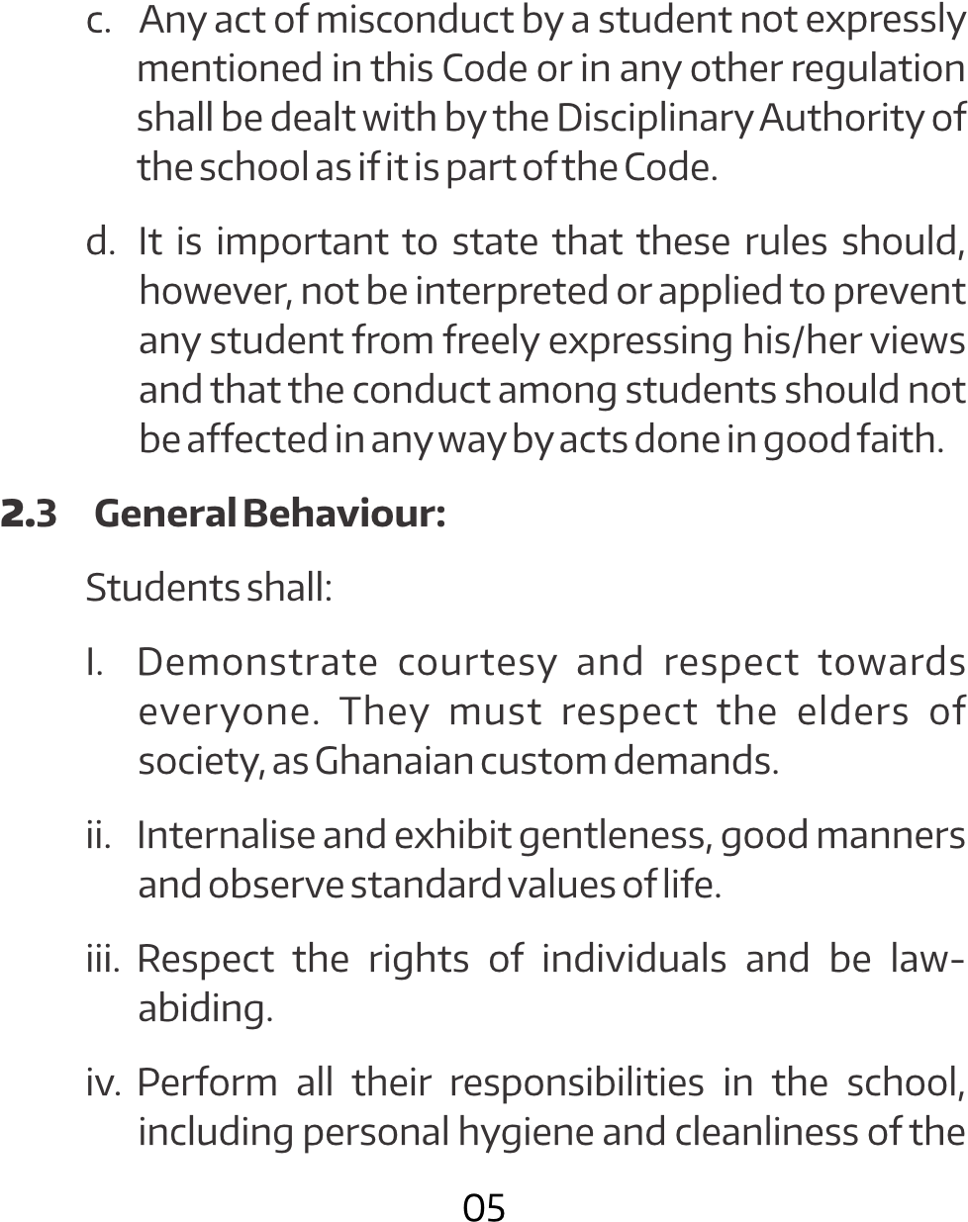

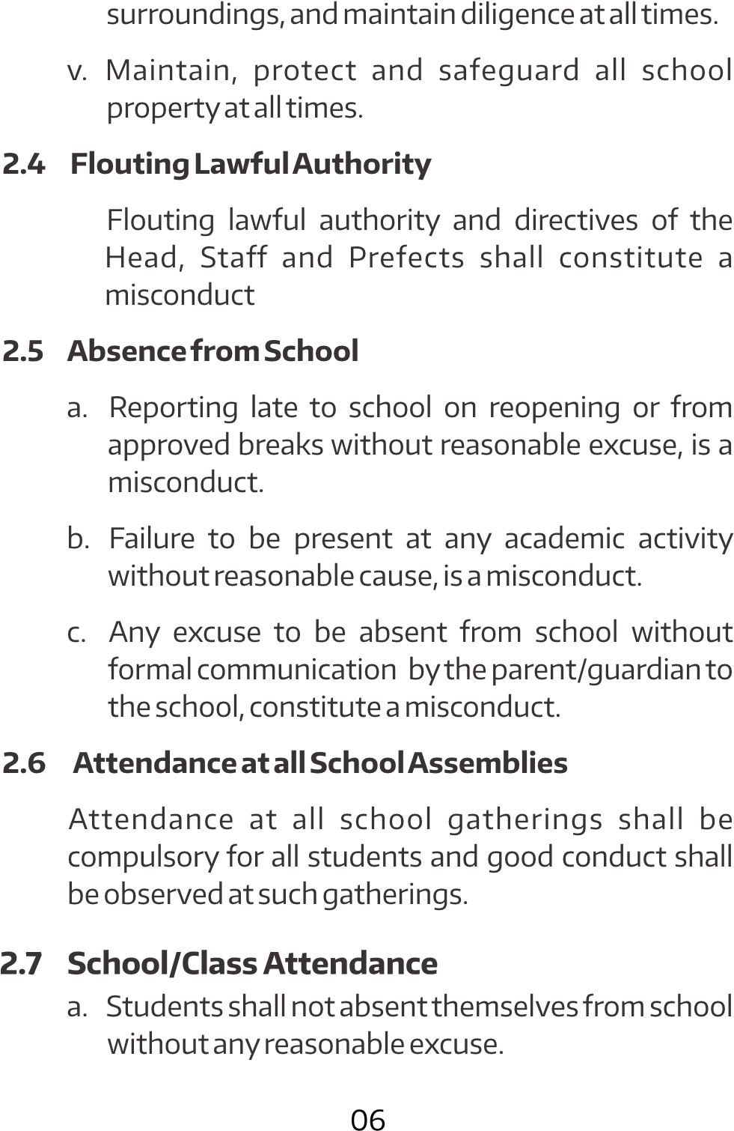

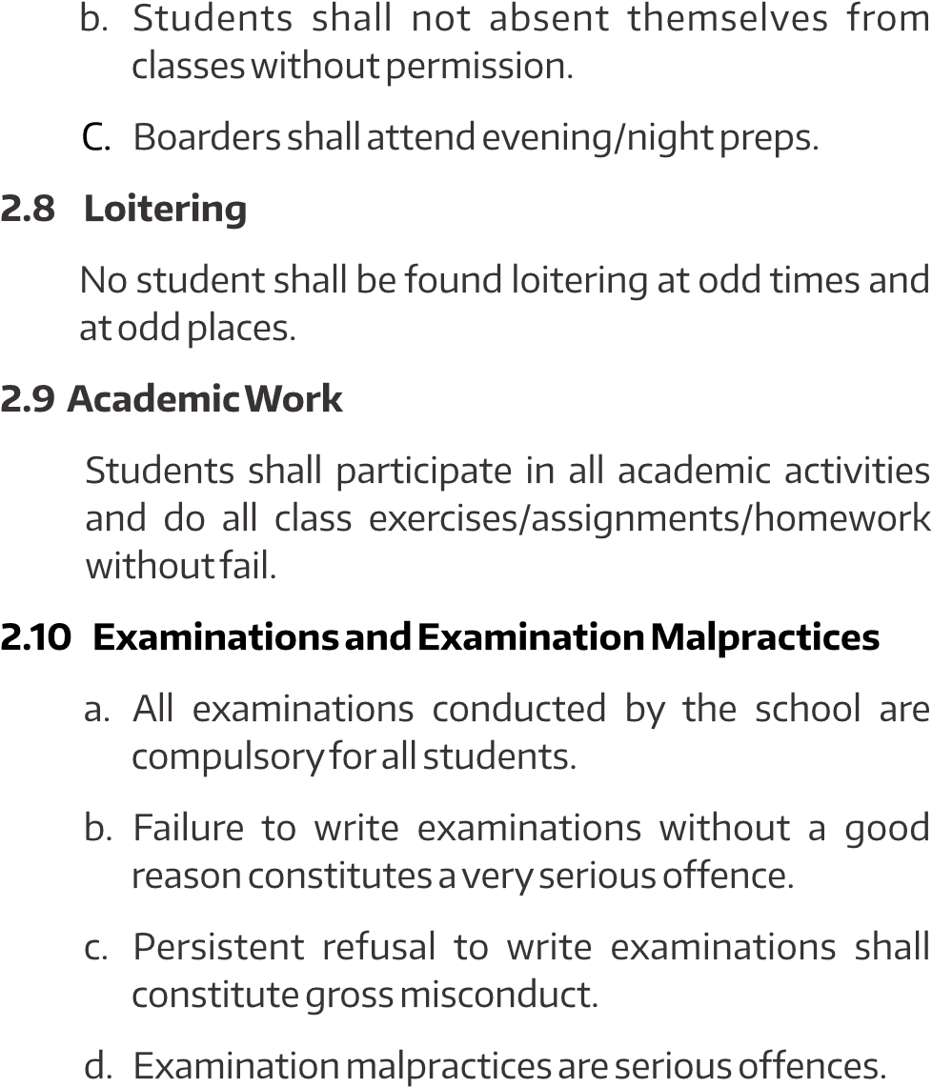

e. Any student who is registered for external examinations by the school but fails to attend classes for a cumulative ten (10) school days without a reasonable excuse constitute a gross misconduct.

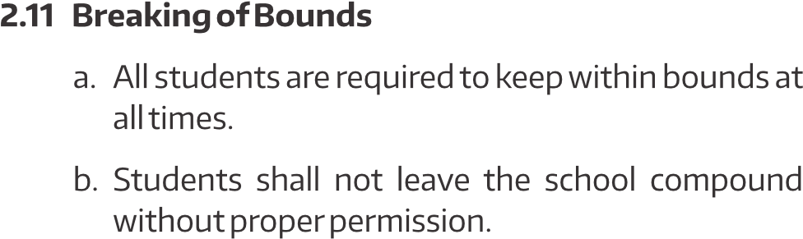c. Staff residence shall be out of bounds to all students except for those students except for 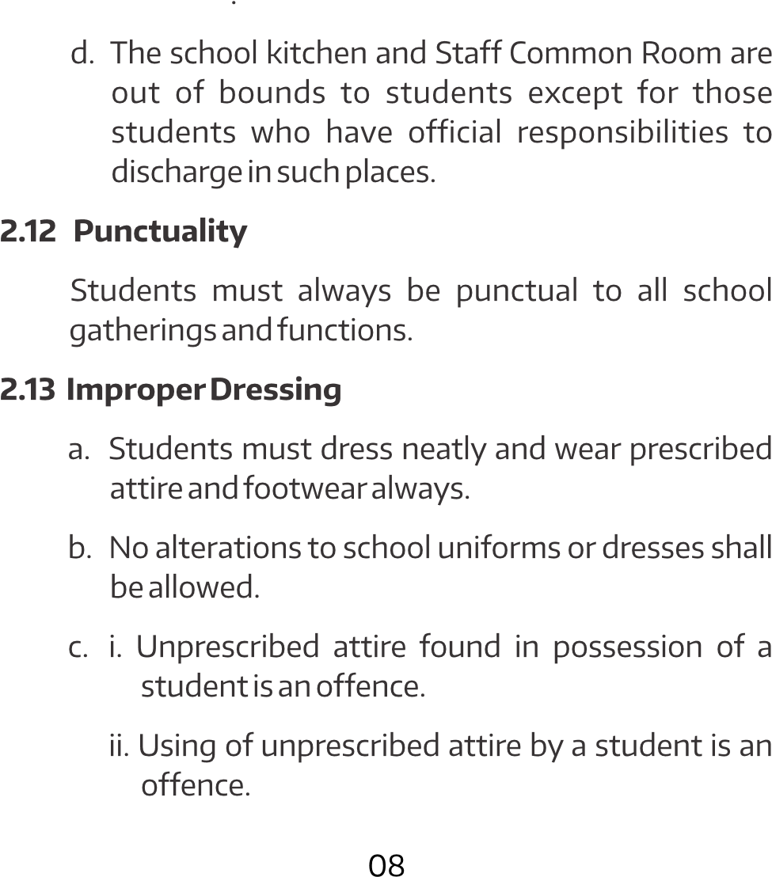official p~~u~~rposes .

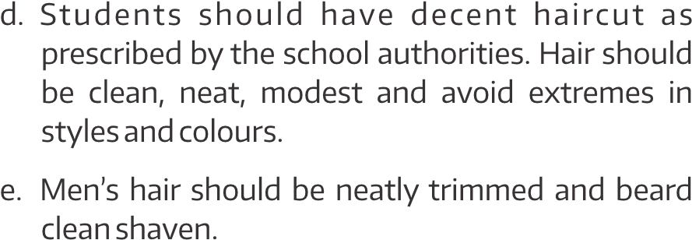

f. Students shall not wear chains, bangles, caps, braces. Wearing of spectacles shall be with medical prescription.

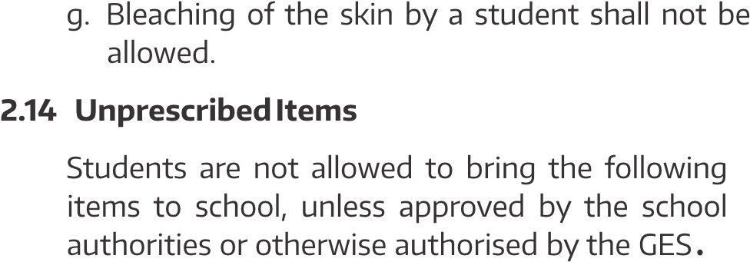

I. Electrical and electronic appliances e.g. kettle, rice cooker, blender, mobile phones, personal computers, headset, music box, pen drives, i-pods, etc.

iii. Alcohol, cigarettes, Indian hemp (wee), and all other edible hard drugs.

**Wilful Damage to School Property**

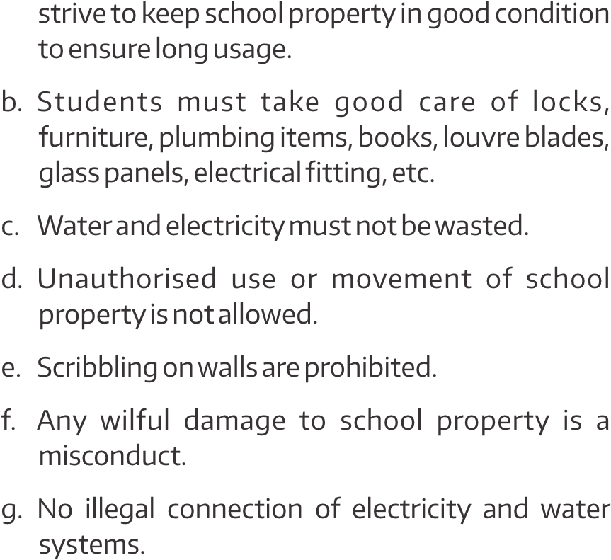

h. Defacing school property shall constitute a misconduct

**2.16 Sexual Offences**

b. Interaction between students in obscure places at odd times constitute an offence.

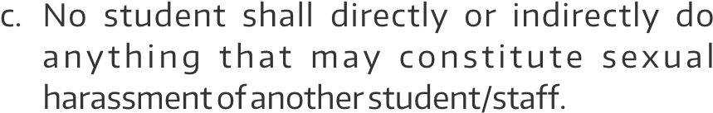

1. The GES guideline for the prevention of pregnancy among school girls and facilitation of Re-Entry into school a er childbirth shall be applied to girls who become pregnant.
2. A victim of rape shall be counselled and guided accordingly.

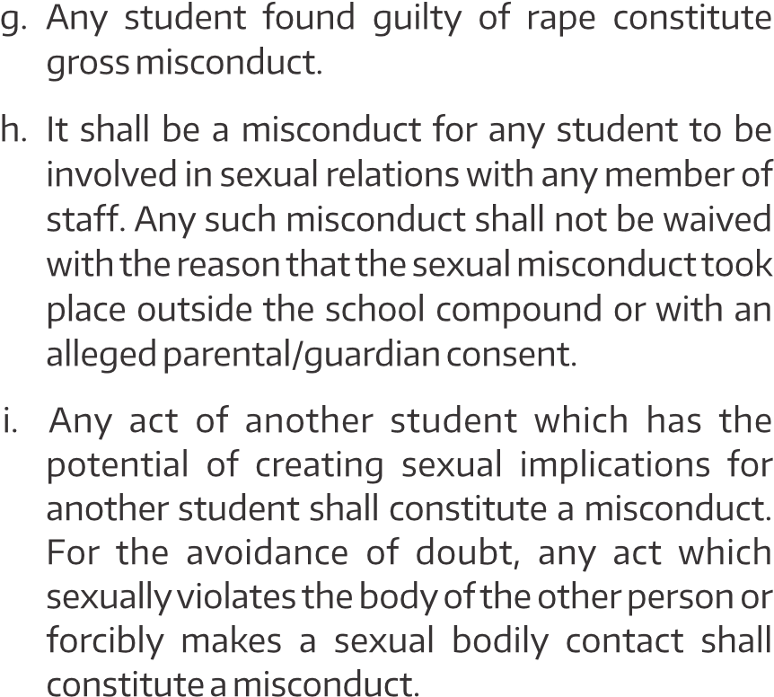

j. Any student who keeps another student from going home for any part of vacation or for any period that the student has sought to go home shall constitute a misconduct.

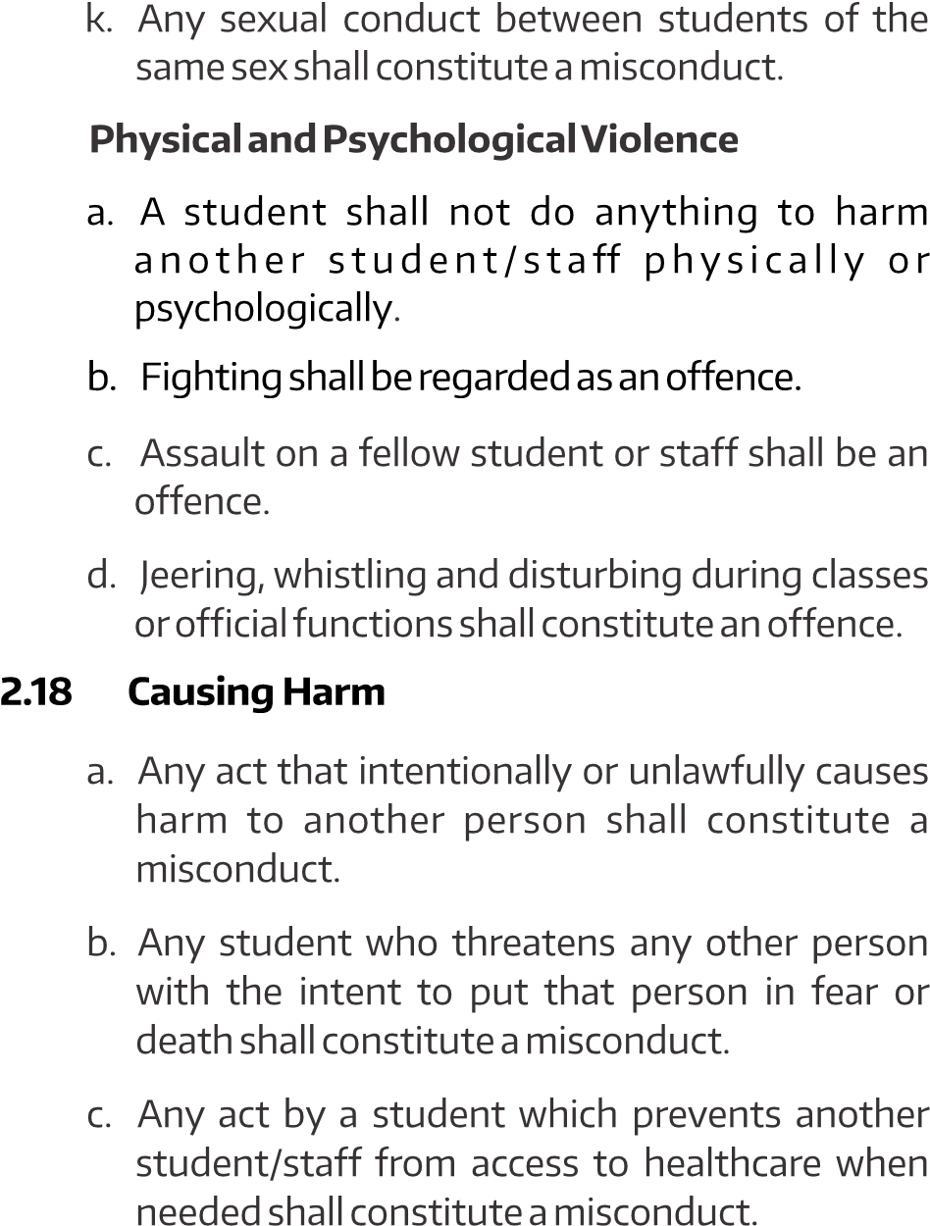**2.17**

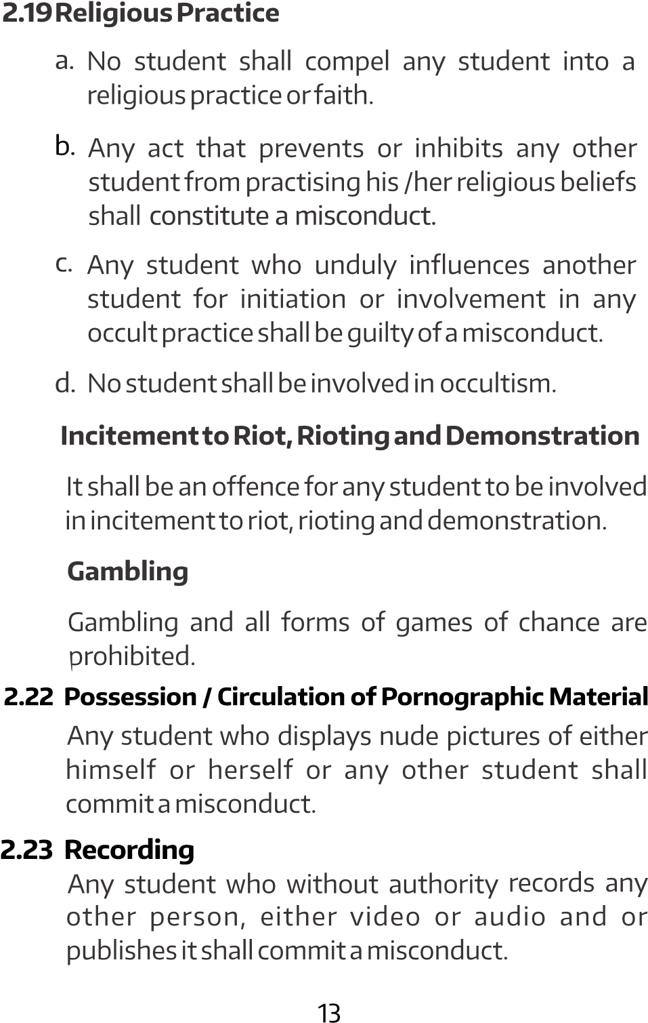**2.20 2.21**

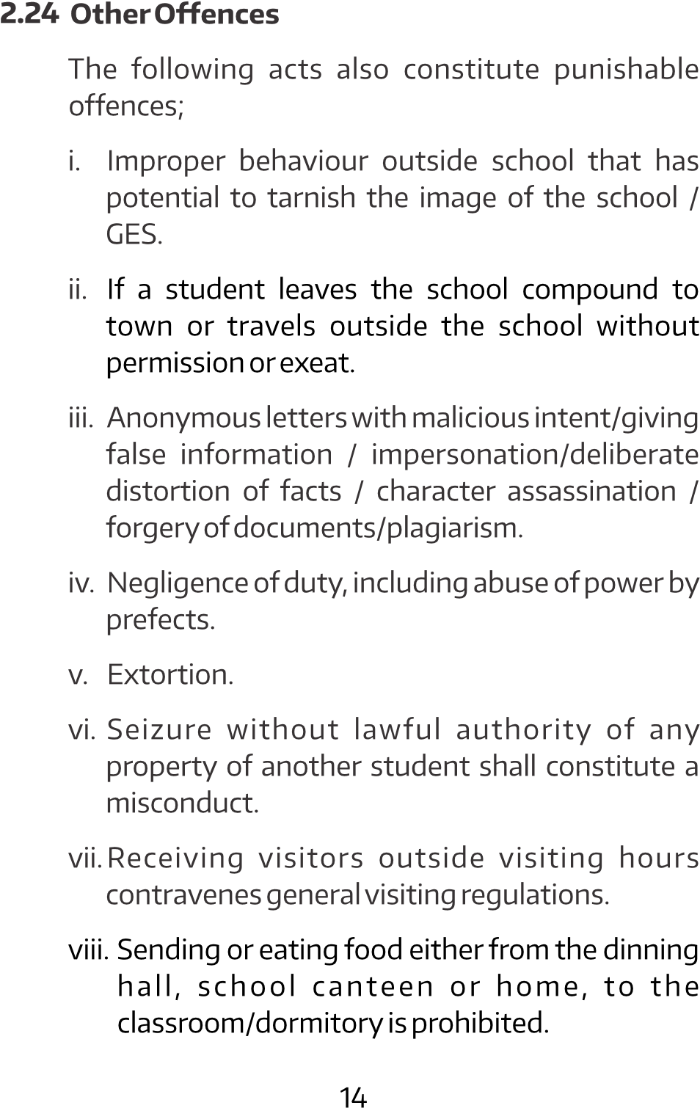

a. Any act of violence that brings harm to students physically, verbally, psychologically or emotionally either perpetrated by peers or staff.

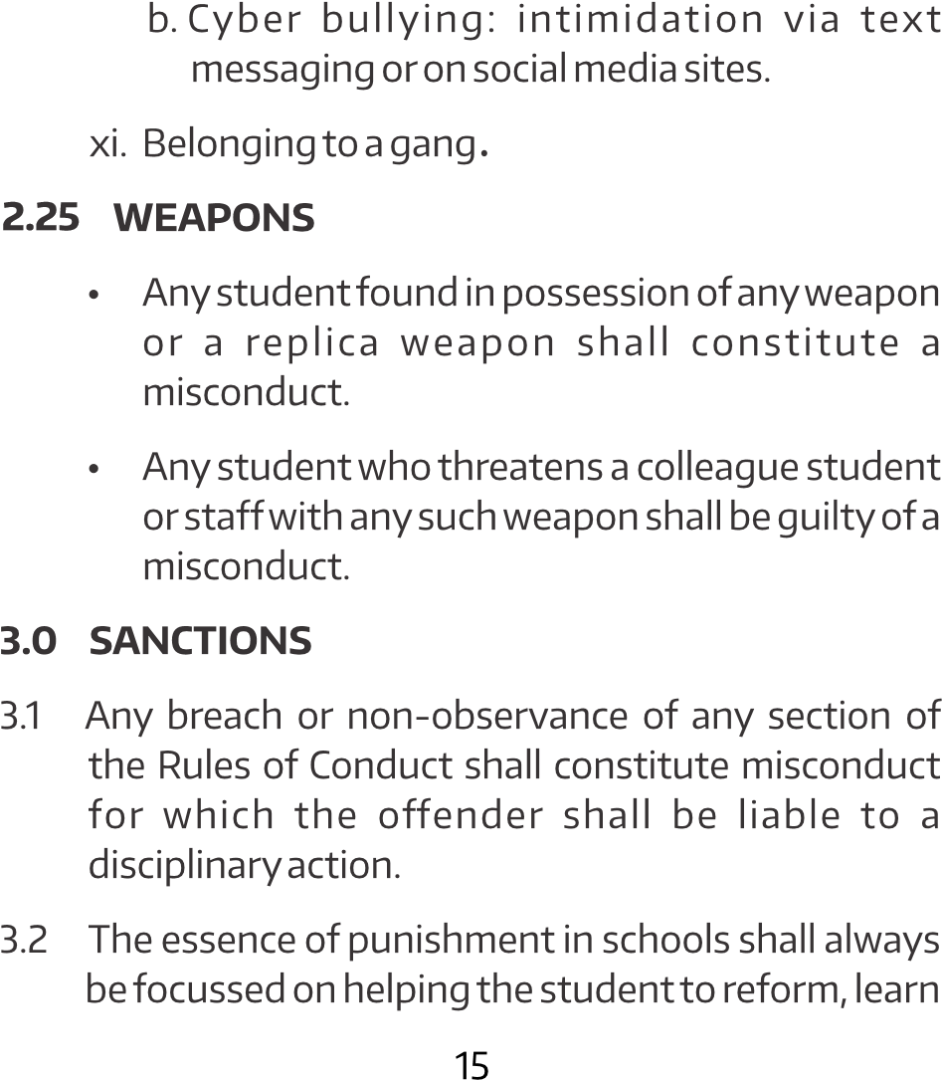

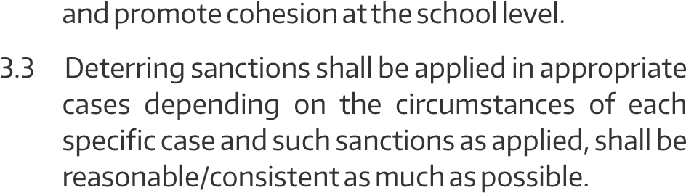

|  |  |  |
| --- | --- | --- |
|  |  |  |
|  |
|  |  |  |
|  |  |  |
|  |  |  |
|  | (truancy) |  |
|  |  |  |

|  |  |  |
| --- | --- | --- |
|  |  |  |
|  |
|  |  |  |
|  |  | Repetition |
|  |  |  |
|  | Refusal to be Punctual |  |
|  |  |  |

|  |  |  |
| --- | --- | --- |
|  |  |  |
|  |
|  |  |  |
|  |  |  |
|  |  |  |
|  |  |  |
| 2.17 |  |  |

|  |  |  |
| --- | --- | --- |
|  |  |  |
|  |
| 2.18 |  |  |
| 2.19 |  |  |
| 2.20 |  |  |
| 2.21 |  |  |

|  |  |  |
| --- | --- | --- |
|  |  |  |
|  |
| 2.22 |  | -Caution and counselling |
| 2.23 |  |  |
| 2.24 | Other Offences |  |

|  |  |  |
| --- | --- | --- |
|  |  |  |
|  |
|  |  |  |

|  |  |  |
| --- | --- | --- |
|  |  |  |
|  |
|  |  |  |
|  |  |
| 2.25 |  |  |